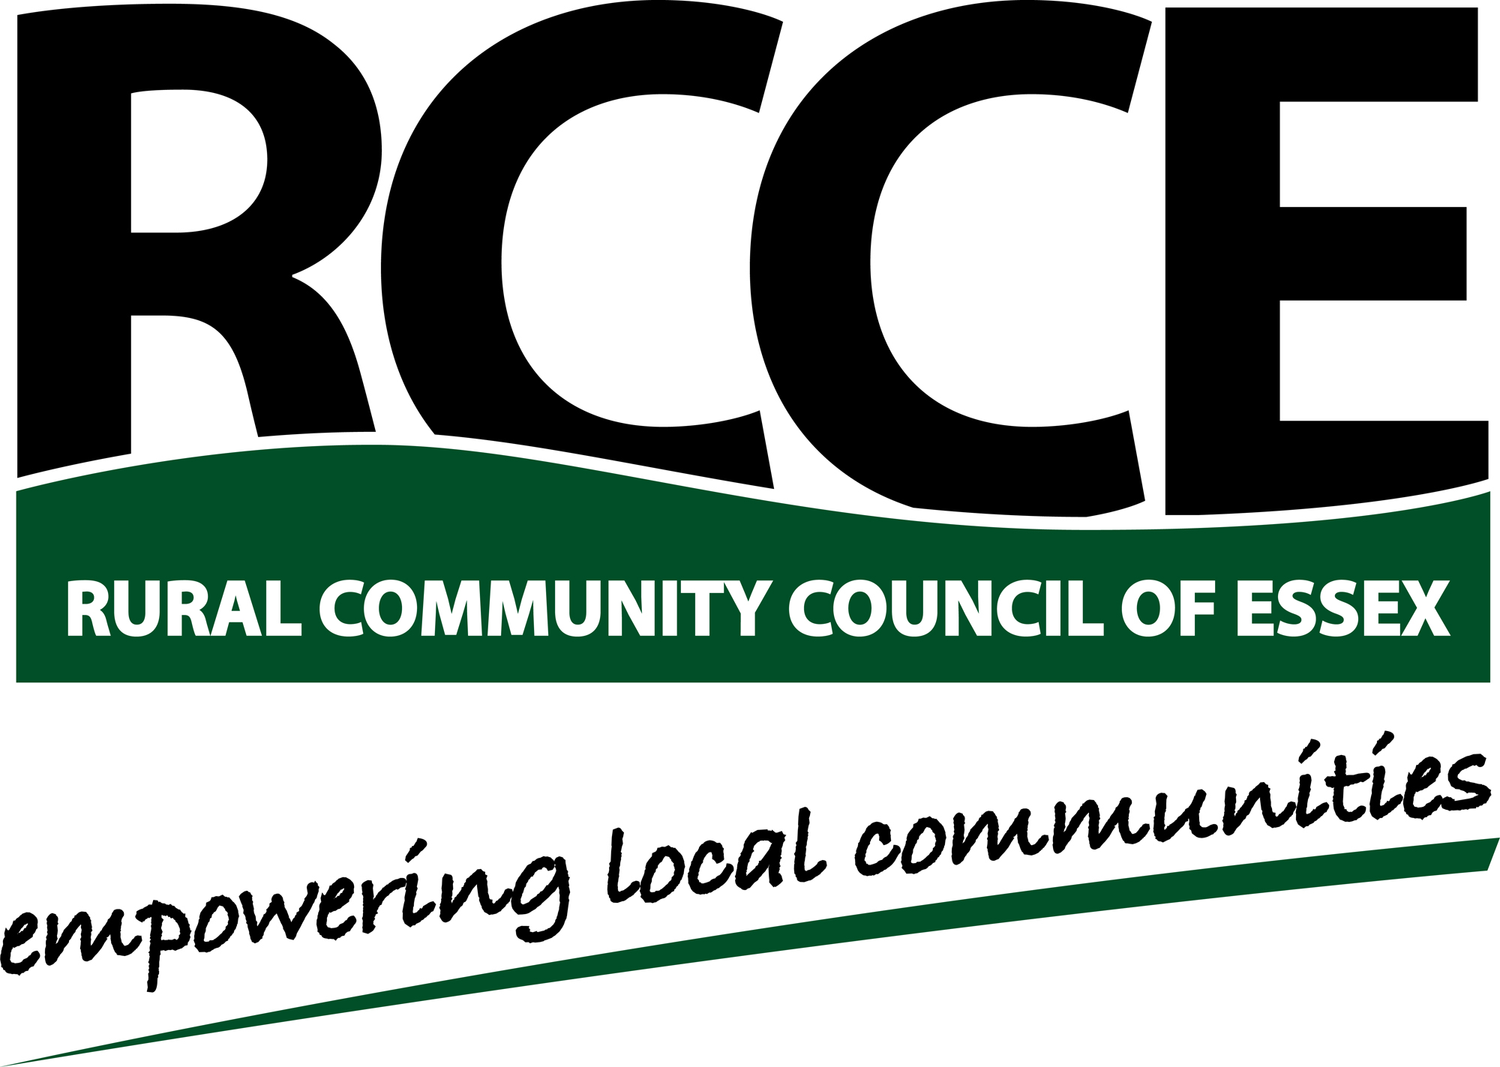


Community Led Planning
Network

Reg. Charity No. 1097009
Company Reg. in England &Wales No. 4609624
Application for Membership (Please complete sections 1 to 3 in block capitals)

1. Group name: (followed by names of all parishes/towns covered by the Group)

(Parish/Town names)

2. Chairman’s name and contact details:
Name:

Address:

Post Code:

Telephone No:

Email:

3. Main Contact: (i.e. Secretary/Treasurer/Parish Clerk)
Name:

Address:

Post Code:

Telephone No:

Email:

4. Payment details: (Annual Fee - £50 +VAT for RCCE Members - £150 +VAT for Non-Members

Please sign and return form with cheque (if payment required) to:
Community Engagement Team, Rural Community Council of Essex, Threshelfords Business Park, Inworth Road, Feering, CO5 9SE.
Tel: 01376 574330 Fax: 01376 573524
Email: sarah.sapsford@essexrcc.org.uk
Cheques payable to: Rural Community Council of Essex.

5. Acceptance - I agree to the Terms and Conditions of the Community Led Planning Network
Office use only: Commencement date: Renewal due:
(Copy Terms and Conditions attached)

Signature Date

